Relationships: The Foundation of Development

When an infant is born, the only organ that is not completely developed is the brain. Parents and other caregivers play a primary role in the development of this complex and amazing part of the body. Infants learn best in the context of consistent and predictable daily experiences in the presence of caregivers whom they love and trust.

The development of communication skills is best promoted through daily routines and activities. It is estimated that the daily activities of feeding, diapering and dressing occur at least 2,000 times during the first year of a child’s life. Each of these provides an opportunity for relationship-building which in turn supports the learning and development of communication skills.

Tip Sheets

Infants: Strategies to Support the Development of Communication Skills

Specific Strategies and Tips:

Responsive Interactions

- Use touch and voice to let infants know they are safe and their needs will be met
- Exaggerate pitch and intonation
- Use shorter sentences and decreased vocabulary
- Use longer pauses between words and utterances
- Frequently repeat words
- Elongate vowels in words
- Use diminutive words such as blankie, doggy, piggy, birdie, etc.
- Comfort and respond to cries and other communicative attempts as readily as possible. Assure infant that she is heard by saying something akin to “I hear you. I am coming”, etc.
- Readily return smiles to facilitate repeated and longer interactions
- Repeat sounds baby makes
- Encourage baby to imitate your sounds
- Talk about what is immediately present
- Talk about what you see and what the baby is looking at wherever you go.
- Play peek-a-boo during daily routines such as dressing, diapering and feeding time (bibs make a great hiding tool)

Using the Environment and Routines

- Arrange the physical environment to promote opportunities to interact frequently
- Position infants so they are able to observe and interact with one another
- Post pictures in diapering area to provide a context for conversation
- Rotate toys to provide interest and novel experiences
- Use words to describe sensory experiences. For example, during feeding time caregivers can talk about taste, texture, color, sound and temperatures of foods.
- Encourage babies to explore objects and toys in a variety of ways (shaking, banging, etc.) and talk about what each child is doing

Reading and Exploring Books

- Read a book or tell a story daily
- Share a book as you cuddle…even with a newborn!
- Provide infants access to books that have simple, bright colored designs and pictures of people and things familiar to them
- Make books using small photo albums and pictures of family members, infants in your program, infants involved in daily activities, etc. You are only limited by your creativity!
- Let infants explore books! (Provide chunky, board or soft bath books for chewing and gumming. There will be time to teach proper care and respect of books later!)
  - Check out the Indestructibles book series at https://goo.gl/Y5oFKk
- Point to pictures and use words to label and describe the characters and what is happening in the story
- Share “lift the flap” books with older infants
- Follow the infant’s lead when sharing a book even though this may mean staying on one page for an extended period of time or looking at the book upside down!

Songs, Rhymes and Finger-Plays

- Infants love language play which includes use of rhyming words, songs and using character voices when reading aloud or telling stories
- Sing a baby’s favorite song over and over again to promote a calmness and a sense of security (Remember, it is the sound of a familiar voice that an infant finds comforting and not the quality of your singing voice)
- Sing silly songs to catch baby’s attention
- Sing songs during transitions
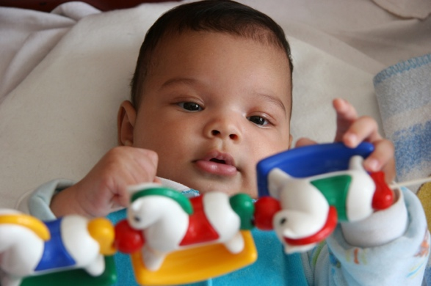

Additional Resources for Supporting the Communication Skills of Infants and Toddlers:

Center for Disease Control and Prevention:
Child Development Positive Parenting Tips
www.cdc.org
Center of Everyday Child Language Learning
http://www.cecll.org/
Talking is Teaching
http://talkingisteaching.org/
Too Small to Fail
http://toosmall.org/community/resources
Zero to Three
http://www.zerotothree.org/

For more information, visit www.inclusivechildcare.org.

Copyright © 2018 Center for Inclusive Child Care, Concordia University, 1282 Concordia Ave. St, Saint Paul, MN 55104. These materials may be freely reproduced for educational purposes.

Information in this tip sheet has been modified from multiple sources.

Funding provided by the Minnesota Department of Human Services.

